Digital Image Processing Exercise Report

Instructor: MITSUGAMI IKUHISA

Student ID: 81322400098

Student Name: GARCIA AARON CALVIN

Date: 2024 07 09

**Summary/Discussion:**

**Algorithm Definition: What is SIFT?**  
SIFT is a computer vision algorithm used to detect and describe local features in images, which allows makes it a suitable tool to perform object recognition, image stitching, and 3D modeling.

**Implementation Description:**

In my implementation of the code, I used cv2’s SIFT() object and its methods to perform the requirements of the reports. I used the famous “Lena” picture that given to me as constant by which I tested my implementation, and gray scaled it to ensure consistency. Lastly, I took video of out of my webcam in order to dynamically perform SIFT, where I held up the same picture of “lena” to get my desired output.

To begin, I read in the image and created the SIFT object. I then called detectAndCompute(), using the gray-scaled image as the input, and a “None” argument to compare it against, which later became the video feed of my webcam. That method returned two arrays: keypoints and descriptors: the latter contains information about the location, scale, and orientation of each keypoint, while the former contains a list of feature vectors that describe the local image regions around each key point. I then created the FLANN-based matcher, and initialized the camera.

After all of that, I initialize a while loop that would run until window displaying the SIFT matching function in real time was closed. While this was occuring, the FLANN-based matcher found the two nearest neighbors for each descriptor in descriptors_pict from descriptors_frame, to which I stored the good matches that were found and displayed them out the image. The results can be seen below.

**Results**

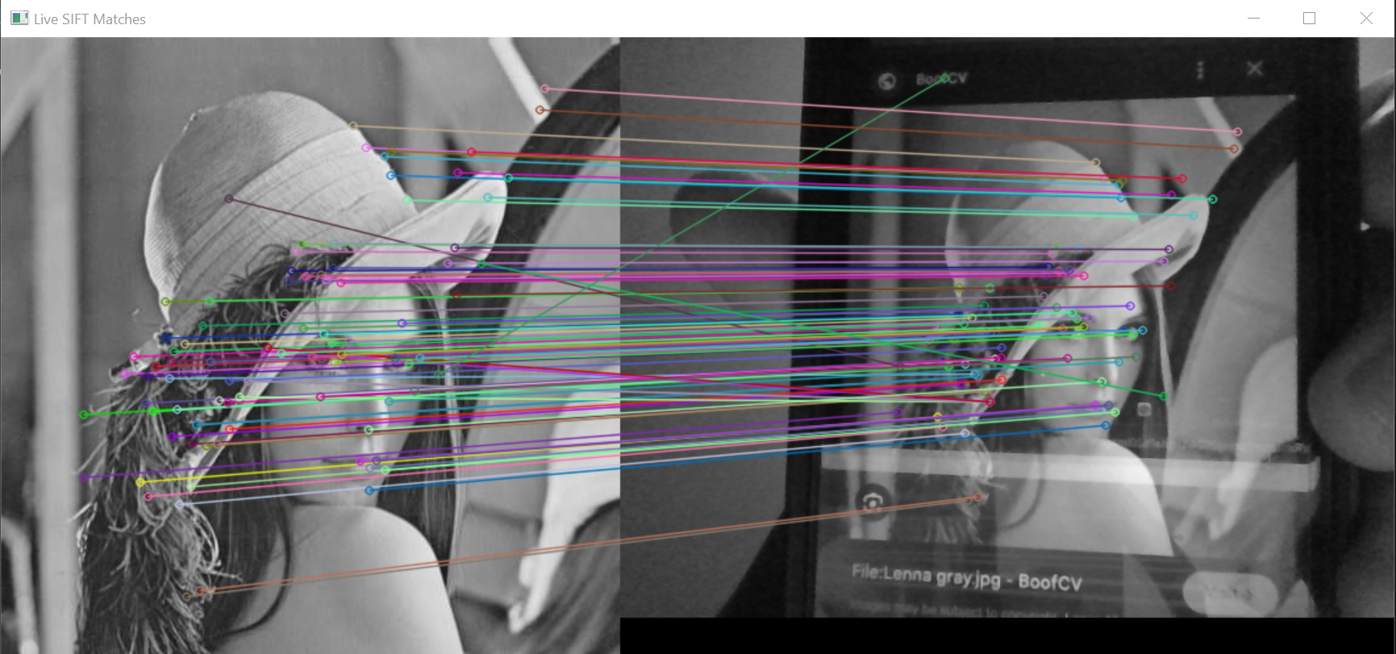**References**

1. Week 13 Slides